Important Note:
-Please the fill the table the same as the sample in the photo below without mentioning as “I” instead, please write as “The candidate” do not mentioned as “He/She”.

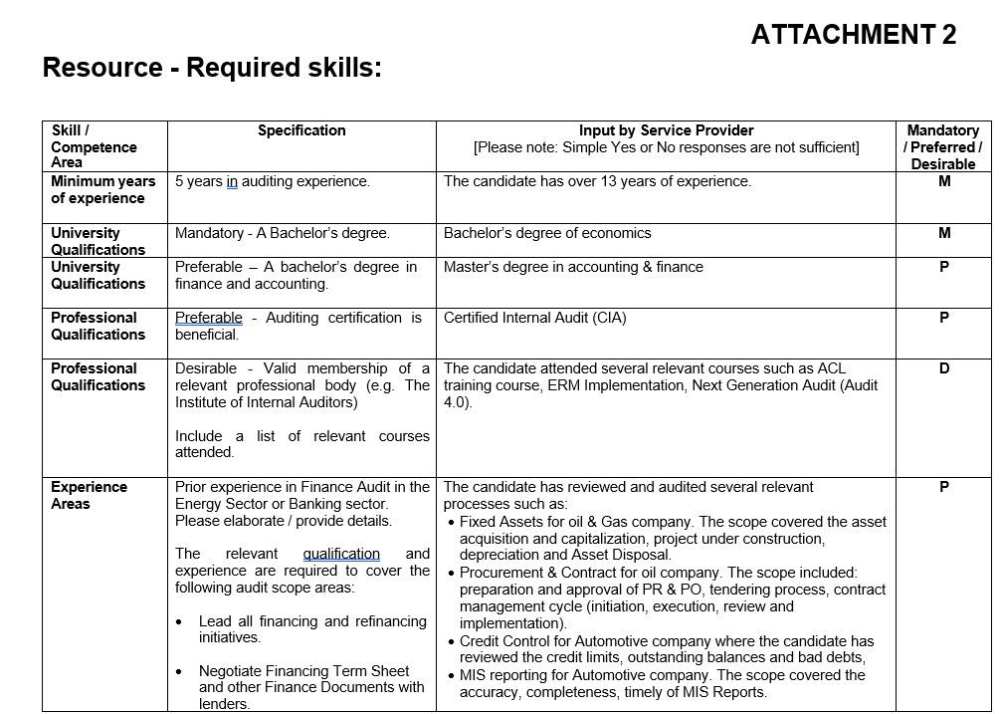
SAMPLE

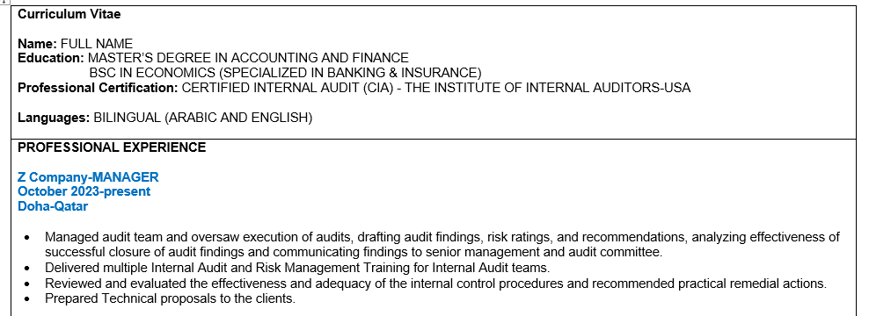
-Please the fill the table in the last page for your CV the same as the sample in the photo below.

SAMPLE

ATTACHMENT 1

Resource – Assignment Details: 25DV06 – QCHEM Audit

Number of Resources required | 4
Category  1- General Auditor  2 -Technical Auditor  3 - IT Auditor | Category 1- General Auditor (1 Auditor)  Category 2- Technical Auditor (3 Auditors)
Dates Required | Fieldwork phase: 04 – 29 May 2025
No. of Working Days | 80 Man days (20 Days for each resource)
Location | Doha, Mesaieed and Ras Laffan
HSE – type of HSE | Office based and Site Safety.
Data Confidentiality – list any specific requirements | Contractor shall not discuss or share any information related to the assignment and obtained during the Audit with any other person outside of the Company Audit Team.
Scope of Services: | To participate as an Auditor in the Company Internal Audit . The objective of the audit is to provide independent assurance to the shareholders on the adequacy and effectiveness of governance, risk management and control processes, including the following Audit areas:  - Governance  - Risk Management  - Corporate Strategic Planning and Performance Management  - Finance  - Human Resources  - Procurement and Contracts  - Supply Chain and Materials Management  - Inventory and Warehouse  - Production and Operations  - Process Safety  - Maintenance

- Asset Integrity
- Health, Safety, and Environment (HSE)
- Engineering Management
- IT / OT
- Measurement and Metering
- Laboratory Operations
- Investments and Project Management
Services required: | - Perform audit work in accordance with Company internal auditing standards and IIA Standards.  - Review, understand and execute the audit program to meet the audit objectives.  - Document the audit testing results in a timely manner, with high quality and adequate working papers (using templates provided).  - Audit findings/observations to be well documented in Audit Memos with adequate supporting documentation.  - Discuss and agree the potential observations / gaps identified with the Lead Auditor on a timely basis.  - Discuss and agree with the auditee/client the agreed observations / gaps  - Document Audit Memos (within 2 days from their identification and agreement) and have them approved by the Lead Auditor.
Audit Areas to be covered | The relevant qualification and experience are required to cover the following audit scope areas: General Auditor:  - Governance  - Risk Management  - Corporate Strategic Planning and Performance Management  - Finance  - Human Resources  - Procurement and Contracts Technical Auditor:  - Supply Chain and Materials Management  - Inventory and Warehouse  - Production and Operations  - Process Safety

- Maintenance
- Asset Integrity
- Health, Safety, and Environment (HSE)
- Engineering Management
- Measurement and Metering
- Laboratory Operations
- Investments and Project Management

ATTACHMENT 2
Resource - Required skills:

Skill / Competence  Area | Specification | Input by Service Provider  [Please note: Simple Yes or No responses are not sufficient] | Mandatory  / Preferred / Desirable
Minimum years of experience | 5 years in auditing experience. |  | M
University  Qualifications | Mandatory - A bachelor’s degree |  | M
University Qualifications | A bachelor’s degree in business administration /finance for Category 1 - General Auditor  A bachelor’s degree in engineering for Category 2 - Technical Auditor |  | M
Professional Qualifications | Preferable - Auditing certification is beneficial. |  | P
Professional Qualifications | Desirable - Valid membership of a relevant professional body (e.g. The Institute of Internal Auditors)  Include a list of relevant courses attended. |  | D
Experience Areas | Prior experience in Business / Finance Audit in the Energy Sector for Category 1  The relevant qualification and experience are required to cover the following audit scope areas: |  | P

General Auditor:
- Governance
- Risk Management
- Corporate Strategic Planning and Performance Management
- Finance
- Human Resources
- Procurement and Contracts
Prior experience in Engineering Audit in the Energy Sector for Category 2

The relevant qualification and experience are required to cover the following audit scope areas:
Technical Auditor:

- Supply Chain and Materials Management
- Inventory and Warehouse
- Production and Operations
- Process Safety
- Maintenance
- Asset Integrity
- Health, Safety, and Environment (HSE)
- Engineering Management
- Measurement and Metering
- Laboratory Operations
- Investments and Project Management
Behavioral | Good judgment and analytical skills (big picture)  Please provide examples. |  | M

Behavioral | Strong organizational skills (scheduling meetings, adequate and timely working papers).  Please elaborate / provide examples. |  | M
Behavioral | Ability to work independently with minimum instructions and supervision from the Lead Auditor.  Has (s)he led many assignments before? Size of assignments that were led. |  | M
Competence | Very good expertise in Data Analytics techniques.  Please provide details/examples of expertise. |  | P
Competence | Advanced knowledge of Microsoft Excel Provide examples in support of response. |  | P
Competence | Good knowledge and use of SAP ERP system |  | P
Communication | Strong written and oral communication skills (in English). This includes the ability to prepare high quality Audit Memos with recommendations.  Provide examples of types of reports prepared. |  | M
Communication | Excellent interpersonal and interviewing skills, including the ability to interact with all levels of management and employees.  Provide examples of levels of management and employees that have been interacted with in the past. |  | M

Location | Is the resource based in Qatar or outside? |  | P

ATTACHMENT 3
Resource - Details

1.0 | Resume submitted for |  |  |  | Photo
 | Request for Proposal No. | 012 |  |  | Photo
 | Experience (no of years) |  |  |  | Photo
 | Base Location |  |  |  | Photo
2.0 | Personal Information |  |  |  | Photo
 | First Name |  | Passport Details
 | Middle Name |  | Passport No.
 | Last name |  | Place of Issue
 | Gender |  | Date of Issue
 | Date of Birth |  | Date of Expiry
 | Marital Status |  | Visa details (if residing in Qatar)
 | Nationality |  | RP/Visa No
 | Previous Nationality (if any) |  | Date of Expiry
 | Religion |  | Sponsor Name
3.0 | Contact Information
 | Contact Address |  | Telephone - Home
 | Contact Address |  | Mob No.
 | Current Location |  | Fax
 | Home Country |  | Email

Curriculum Vitae

Name:
Education:
Professional Certification:

Languages:

PROFESSIONAL EXPERIENCE

Company- POSITION
Date
Country

- Job description/experience

